GROUP 6

Members
Parsley Njoroge - Sct211-0007/2023
Patrick Leon – Sct211-0003/2023

Q1. Banner Creation Using OpenGL and Python
Introduction
This assignment illustrates the creation of a graphical banner including the text “JKUAT ROCKS” through two distinct methodologies: OpenGL (C++) and Python (Pillow library). The aim was to provide styled text with appropriate alignment, color difference, and background design.
OpenGL Implementation
Approach
The OpenGL solution use GLUT stroke fonts for rendering scaled text. As a result of the absence of automated text alignment in OpenGL, manual computations were executed to achieve text centering.
Key Components
a) Rendering Text
A custom function renderStrokeText() was created to draw each character using:
glTranslatef() for positioning
glScalef() for resizing
glutStrokeCharacter() for rendering characters
b) Calculating Text Width
To center the text, the width of each word was calculated using:
glutStrokeWidth()
This allowed computation of:
Width of “JKUAT”
Width of “ROCKS”
Total width including spacing
c) Centering Logic
The starting X position was calculated using:
startX = −(totalWidth / 2) ​
This ensures the entire phrase is centered horizontally.
d) Color Application
JKUAT → Green using glColor3f(0,1,0)
ROCKS → Red using glColor3f(1,0,0)
e) Enhancements
Anti-aliasing using GL_LINE_SMOOTH
A white rectangular border using GL_LINE_LOOP
f) Interactivity
Keyboard controls were added:
+ increases size of texts
- decreases size of texts
This allows dynamic scaling of the banner.
Coding Implementation
#include <GL/glut.h>

float scale = 0.002f;
// Function to draw scalable stroke text
void renderStrokeText(float x, float y, float scale, const char* string) {
glPushMatrix();
glTranslatef(x, y, 0);
glScalef(scale, scale, 1);

for (const char* c = string; *c != '\0'; c++) {
glutStrokeCharacter(GLUT_STROKE_ROMAN, *c);
}
glPopMatrix();
}

float getStrokeTextWidth(const char* text) {
float width = 0.0f;
for (const char* c = text; *c != '\0'; c++) {
width += glutStrokeWidth(GLUT_STROKE_ROMAN, *c);
}
return width;
}

// Display function
void display() {
glClearColor(0.6f, 0.3f, 0.2f, 1.0f);
glClear(GL_COLOR_BUFFER_BIT);

const char* text1 = "JKUAT";
const char* text2 = "ROCKS";

// Calculate widths
float width1 = getStrokeTextWidth(text1) * scale;
float width2 = getStrokeTextWidth(text2) * scale;

// Total width (with spacing between words)
float spacing = 0.05f;
float totalWidth = width1 + width2 + spacing;

// Starting X (centered)
float startX = -totalWidth / 2;

glEnable(GL_LINE_SMOOTH);
glHint(GL_LINE_SMOOTH_HINT, GL_NICEST);
glEnable(GL_BLEND);
glBlendFunc(GL_SRC_ALPHA, GL_ONE_MINUS_SRC_ALPHA);

// Draw JKUAT (Green)
glColor3f(0.0f, 1.0f, 0.0f);
renderStrokeText(startX, 0.0f, scale, text1);

// Draw ROCKS (Red)
glColor3f(1.0f, 0.0f, 0.0f);
renderStrokeText(startX + width1 + spacing, 0.0f, scale, text2);

// Draw border
glColor3f(1.0f, 1.0f, 1.0f);
glLineWidth(3);

glBegin(GL_LINE_LOOP);
glVertex2f(-0.95f, -0.8f);
glVertex2f(0.95f, -0.8f);
glVertex2f(0.95f, 0.8f);
glVertex2f(-0.95f, 0.8f);
glEnd();
glFlush();
}

void reshape(int w, int h) {
glViewport(0, 0, w, h);
glMatrixMode(GL_PROJECTION);
glLoadIdentity();
if (w <= h)
gluOrtho2D(-1.0, 1.0, -1.0 * (GLfloat)h / (GLfloat)w, 1.0 * (GLfloat)h / (GLfloat)w);
else
gluOrtho2D(-1.0 * (GLfloat)w / (GLfloat)h, 1.0 * (GLfloat)w / (GLfloat)h, -1.0, 1.0);
glMatrixMode(GL_MODELVIEW);
}

void keyboard(unsigned char key, int x, int y) {
if (key == '+') {
scale += 0.0002f; // Increase size
}
else if (key == '-') {
if (scale > 0.0002f) scale -= 0.0002f; // Decrease size
}
glutPostRedisplay(); // Tell OpenGL to redraw the screen
}

// Initialize projection
void init() {
glMatrixMode(GL_PROJECTION);
glLoadIdentity();
gluOrtho2D(-1, 1, -1, 1);
}

// Main function
int main(int argc, char** argv) {
glutInit(&argc, argv);
glutInitWindowSize(800, 400);
glutCreateWindow("JKUAT Banner");

init();
glutDisplayFunc(display);
glutReshapeFunc(reshape);
glutKeyboardFunc(keyboard);
glutMainLoop();
return 0;
}
Results
Default Result
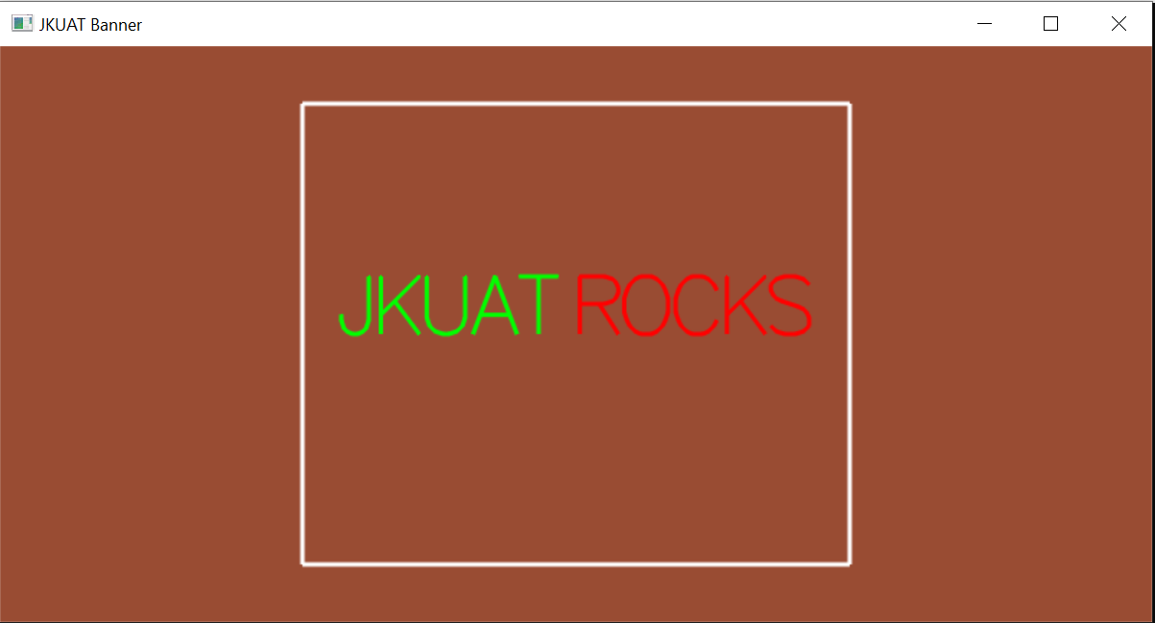
Increased size
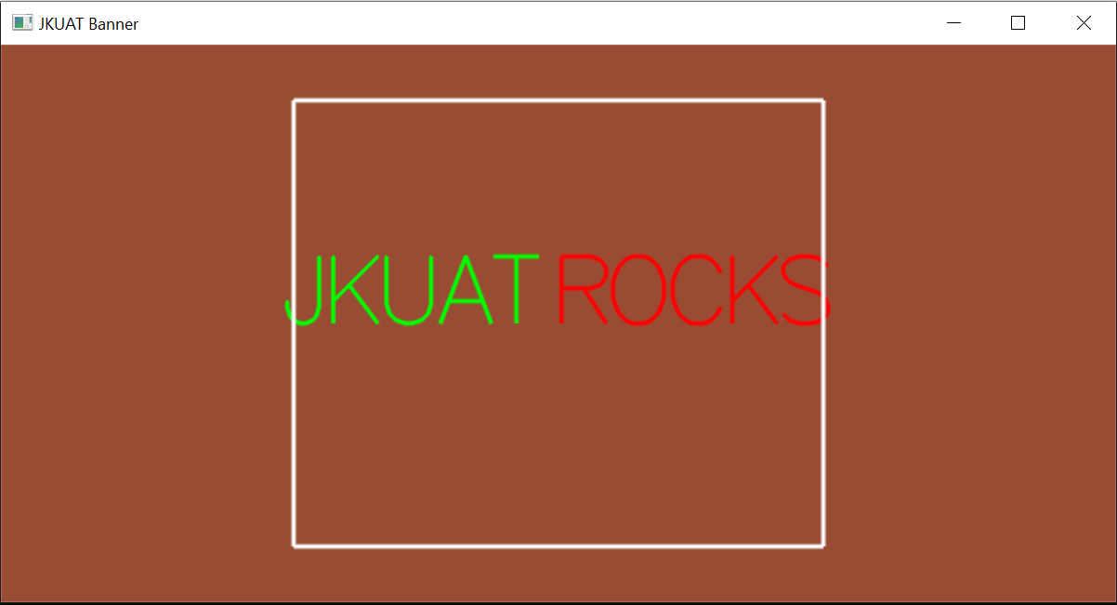
Reduced size
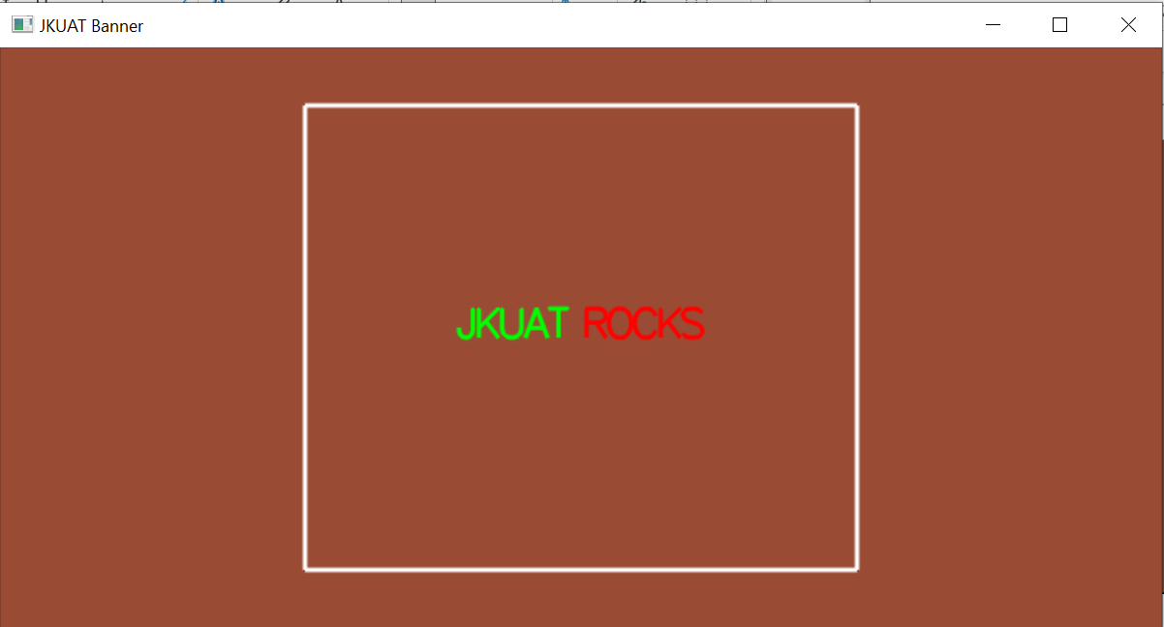

Python Implementation
Approach
The Python solution makes use of the Pillow (PIL) library to create and manipulate an image.
Key Components
a) Image Creation
A blank image was created using:
Image.new()
Background color set to brown
b) Font Handling
A TrueType font (arial.ttf) was loaded using:
ImageFont.truetype()
c) Text Measurement
To center the text:
draw.textlength() was used to calculate width
draw.textbbox() was used to calculate height
d) Centering Logic
The position was calculated using:
x = (image width−text width) / 2
​ y = (image height−text height) / 2
e) Rendering Colored Text
JKUAT is drawn in green
ROCKS is drawn in red after
This ensures correct spacing and alignment.
f) Output
The banner is displayed using image.show()
Coding Implementation
from PIL import Image, ImageDraw, ImageFont

def create_centered_banner():
# Setup the canvas
width, height = 1000, 400
brown_bg = (139, 69, 19)
image = Image.new("RGB", (width, height), brown_bg)
draw = ImageDraw.Draw(image)

# Load the font
try:
font = ImageFont.truetype("arial.ttf", 80)
except IOError:
font = ImageFont.load_default()

# Define the text and colors
text_part1 = "JKUAT "
text_part2 = "ROCKS"
full_text = text_part1 + text_part2

green = (0, 255, 0)
red = (255, 0, 0)

# Calculate total dimensions of the combined text
total_width = draw.textlength(full_text, font=font)

# Get the bounding box to find the true height of the text
# textbbox returns (left, top, right, bottom)
left, top, right, bottom = draw.textbbox((0, 0), full_text, font=font)
total_height = bottom - top

# Calculate perfectly centered X and Y coordinates
start_x = (width - total_width) / 2
start_y = (height - total_height) / 2

# Draw Part 1 (Green) at the calculated center-start position
draw.text((start_x, start_y), text_part1, font=font, fill=green)

# Get the width of Part 1
part1_width = draw.textlength(text_part1, font=font)

# Draw Part 2 (Red) immediately after Part 1
draw.text((start_x + part1_width, start_y), text_part2, font=font, fill=red)

# Display and save
image.show()
image.save("jkuat _banner.png")
print("Centered banner saved successfully!")

if __name__ == "__main__":
create_centered_banner()

Results
Default
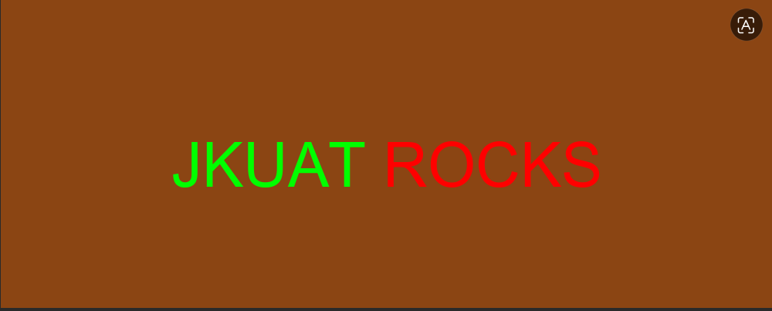
Increased Font
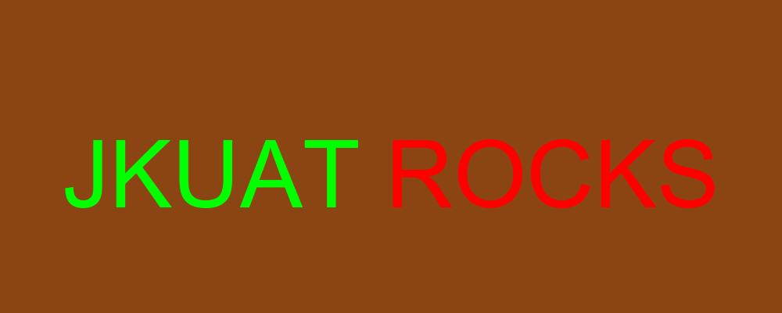
Reduced Font

Conclusion
The banner was successfully generated using both of these implementations. Python was able to provide simplicity and accurate text measurement, while OpenGL was able to facilitate interaction and real-time display. When you compare the two methods, you can see that OpenGL gives you a greater degree of authority and interactivity, but it also requires more work and a deeper understanding of technology. On the other hand, Python's Pillow module is better at making static pictures and is easier to use, especially when it comes to displaying text and laying things up.

